# ITC205/515 Assignment 3 Design materials

Assignment 3 revolves around developing support for a self-service Library system. The main aim of the new system is to allow borrowers to self-support in terms of finding and borrowing books. The system should also help staff to manage books.

It has been determined that the most important functionality required by the new system is the ability to borrow a book. Consequently, initial analysis and design activity have centred on developing a specification for the use case **‘Borrow a Book’**.

What follows are some documents detailing the requirements for the ‘Borrow a Book’ use case.

These documents include:

1. A use case diagram for the library system
2. A domain model for the library system.
3. A full use case description for the ‘Borrow Book’ use case.
4. An activity diagram equivalent to the full use case.
5. A design class diagram for the entity and data access classes necessary to support the use case.
6. A set of 3 state diagrams, one for each entity class.
7. A sequence diagram showing a sequence of messages which can support the use case.
8. A software requirement specification document detailing the requirements for those entity and data access classes
9. A set of system operation specifications detailing the requirements for the system operations required to support the use case.

**Please Note:** in the event of any conflict between a diagram and the textual specifications, the textual specifications take precedence.

## Assignment Guidelines

The assignment centres on a hierarchy of dynamic testing, starting with low level unit testing, low level integration testing, higher level integration testing, ‘system’ testing and eventually user acceptance testing.

Carry out the following testing steps:

1. Implement and unit test any of the Member, Loan, or Book objects.*
2. Implement and unit test the associated DAO and helper obejcts.*
3. Carry out low level integration testing of the Entity, DAO, and helper object interaction.
4. Carry out high level integration testing by implementing and testing the ‘swipe card’, ‘scan book’ and ‘confirm loan’ system operations.**
5. Carry out ‘system’ level testing by simulating use case scenarios to drive the ‘borrow book’ control class.
6. Carry out user acceptance testing by integrating the supplied UI classes, and designing and carrying out UAT using the supplied UAT templates.

*Use mock objects to isolate the object subjected to unit tests.

**You may contact the lecturer to provide implementations of those sections of the application you have not implemented and tested in steps 1, 2, and 3.

## Library System Use Case Diagram

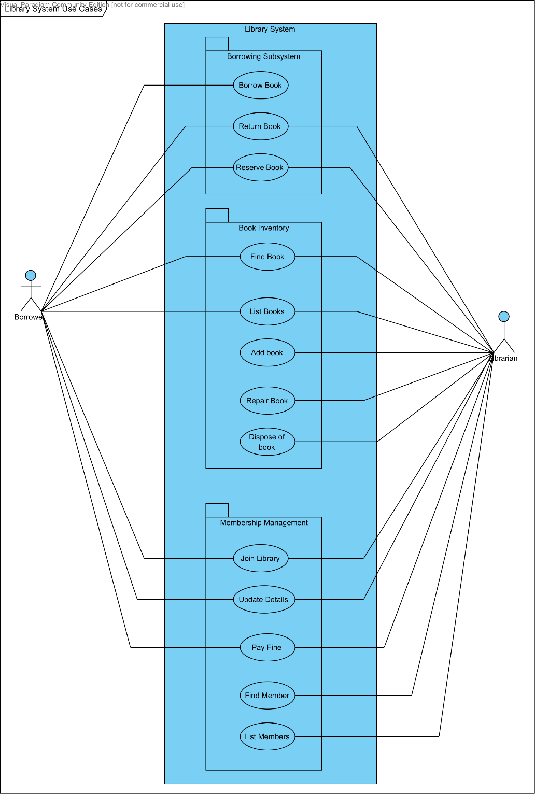

## Library System Domain Model

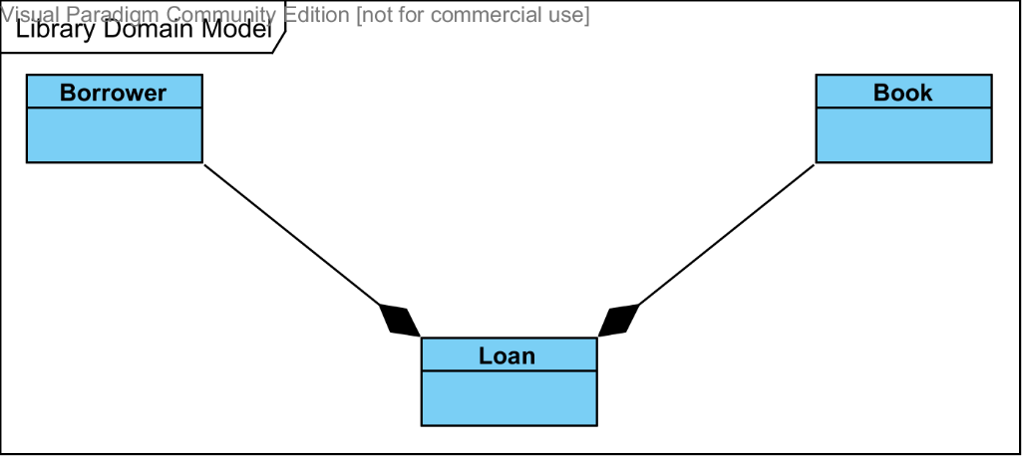

## Full Use Case Description: Borrow Book

**1 Brief Description**

A borrower swipes their library card. If there are no borrowing restrictions they then scan the barcode of each book they wish to borrow. When they have scanning all the books they wish to borrow, a loan slip is printed.

**2 Actor Brief Descriptions**

2.1 Borrower:A member of the library who wishes to borrow a book.

**3 Preconditions**

3.1 The borrower must be a member of the library with a valid membership card.

3.2 All books selected must be shelved in the public area, and have valid book barcodes identifying them to the library system.

**4 Normal Flow of Events**

|  |  |  |
| --- | --- | --- |
| Step | Actor | System |
| 1 | 1.1 The use case begins when the borrower initiates a loan at the self-service station. | 1.2 The system prompts the user to swipe their library card  1.3 The system enables the car reader. |
| 2 | 2.1 The borrower swipes their library card through the library card reader. | 2.2 The system retrieves the borrower’s details.  2.3 The system displays the borrower’s details.  2.4 The system enables the scanner |
| 3 | 3.1 The borrower scans the book barcode using the book barcode scanner | 3.2 The system retrieves the book’s details.  3.3 The system displays the book’s details.  3.4 The system creates a new pending loan for the book  3.5 The system adds the new pending loan to the pending loan list.  3.6 The system displays the current pending loan list. |
| 4 | 4.1 The borrower indicates they have finished scanning books. | 4.2 The system disables the scanner.  4.3 The system displays the finalized pending loan list. |
| 5 | 5.1 The borrower confirms the finalized pending loan list. | 5.2 The system records the confirmed loans.  5.3 The system prints a borrowing slip.  5.4 The use case terminates. |

**5 Alternate Flows**

* 1. **Borrowing Restrictions Apply**

If at step 2.2 of the basic flow the system finds that the borrower has borrowing restrictions due to overdue loans, having borrowed the maximum number of books permitted, or exceeding the maximum amount of fines owing, then:

|  |  |  |
| --- | --- | --- |
| Step | Actor | System |
| 2.2 |  | 2.2.1 The system displays a borrowing restriction message.  2.2.2 The system disables the book scanner |
|  | 2.2.3 The user cancels the book borrowing process. |  |

The use case terminates.

* 1. **Borrowing Multiple Books**

If at step 4.1 the borrower indicates that they want to scan more books:

|  |  |  |
| --- | --- | --- |
| Step | Actor | System |
| 4.1 | 4.1.1 The borrower indicates they wish to scan more books. | 4.1.2 The system leaves the scanner enabled |

The use case repeats from the beginning of step 3.

* 1. **Loan Limit Reached**

If at step 4.1.1 the borrower indicates that they want to scan more books, but borrowing an additional book would cause them to exceed the loan limit:

|  |  |  |
| --- | --- | --- |
| Step | Actor | System |
| 4.1.1 |  | 4.1.2.1 The system displays a message telling the user they have reached the loan limit. |

The normal flow is resumed at step 4.2.

* 1. **Finalized Loan List Rejected**

If at step 5.1 the borrower changes their mind about what books to borrow:

|  |  |  |
| --- | --- | --- |
| Step | Actor | System |
| 5.1 | 5.1.1 The borrower rejects the finalized loan list. | 5.1.2 The system clears the current pending loan list. |

The normal flow is resumed at step 3.

* 1. **Borrowing Cancelled**

If at any step, up until step 5.1, the user decides not to borrow any books:

|  |  |  |
| --- | --- | --- |
| Step | Actor | System |
| X | X.1 The user cancels the book borrowing process. | X.2 The system clears the pending loan list |

The use case terminates

## Activity Diagram: Borrow Book

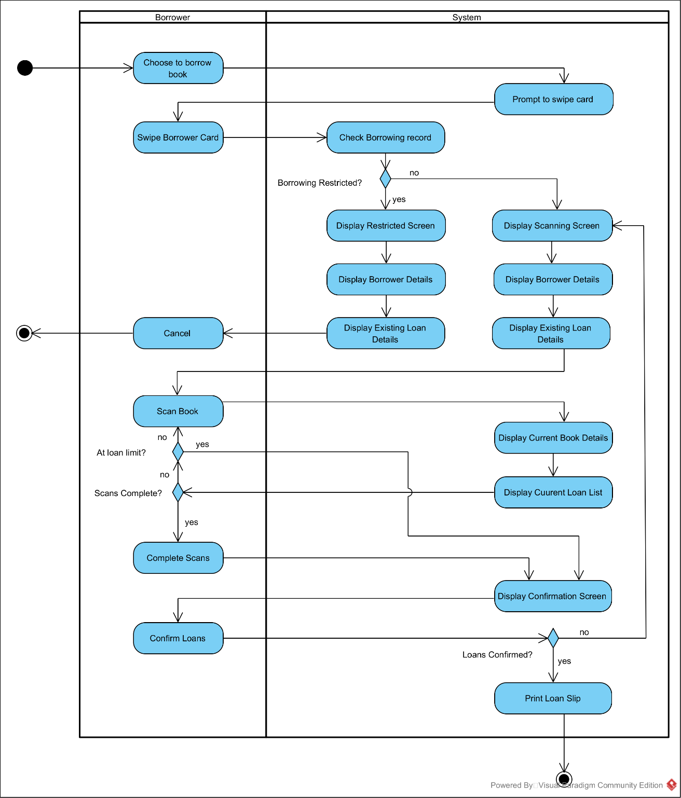

## Design Class Diagram: Borrow Book Collaboration

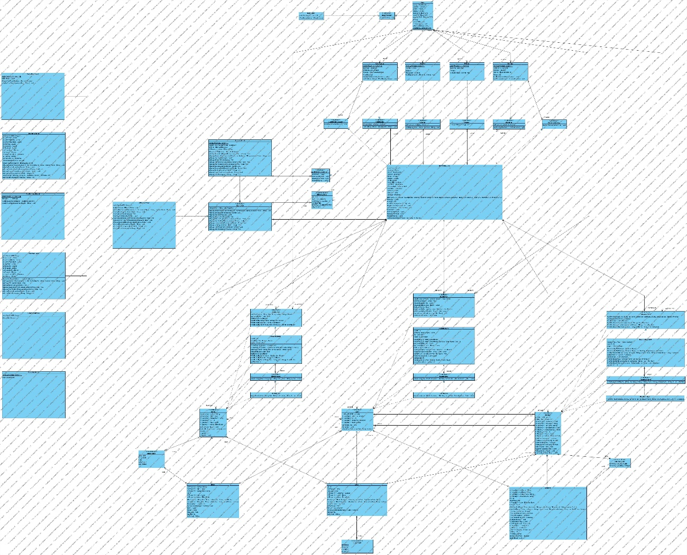

## State Diagram: Borrower

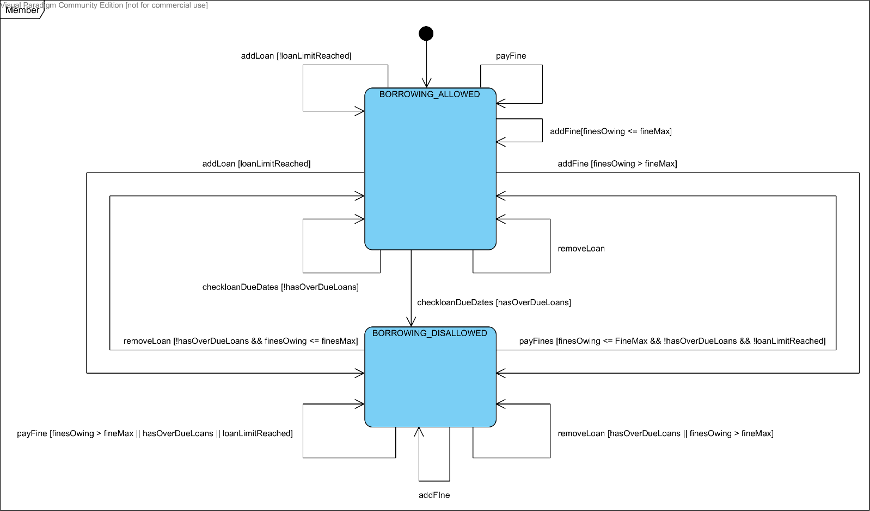

## State Diagram: Book

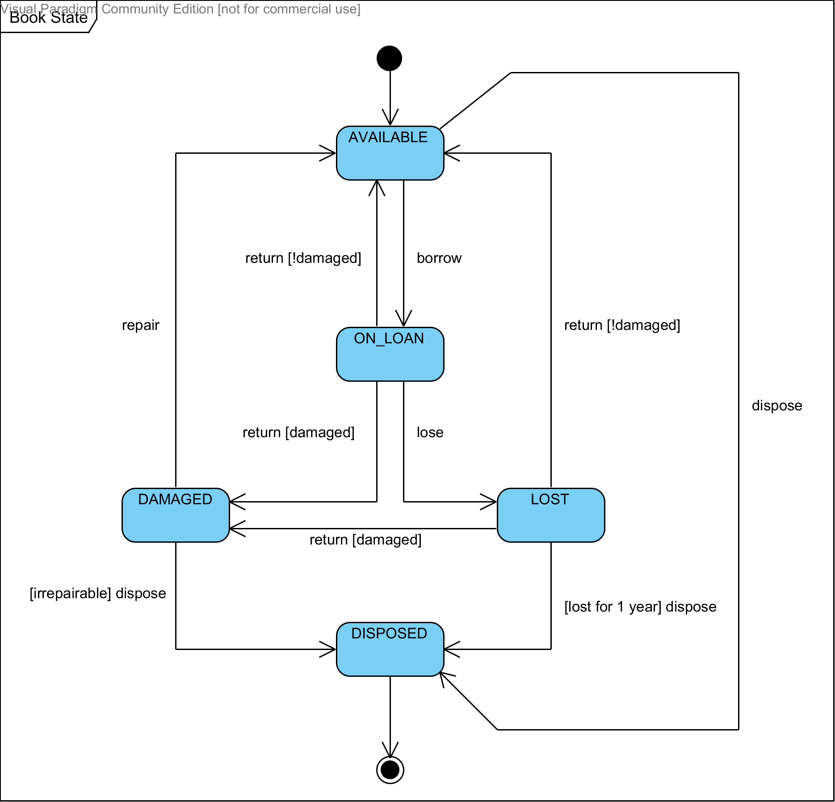

## State Diagram: Loan

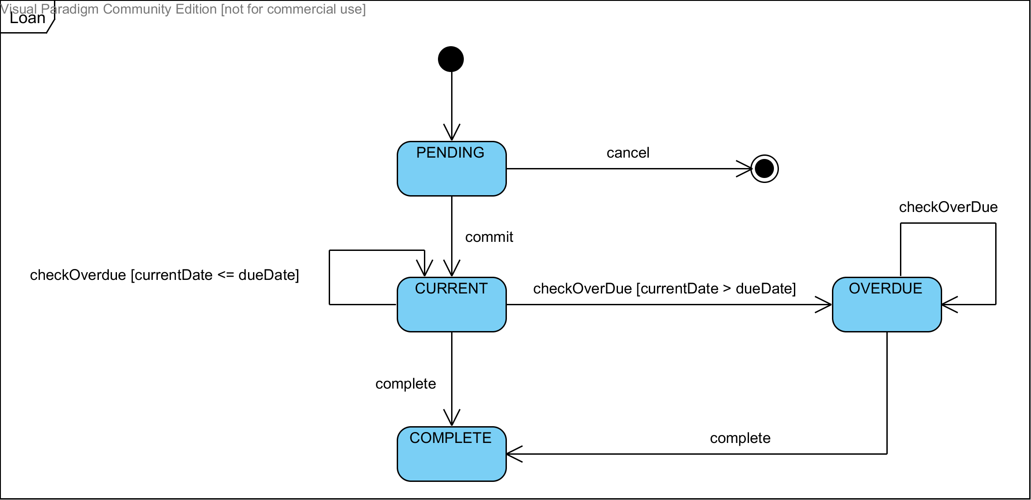

## Sequence Diagram: Borrow Book

### Borrow Book SSD – Normal Flow

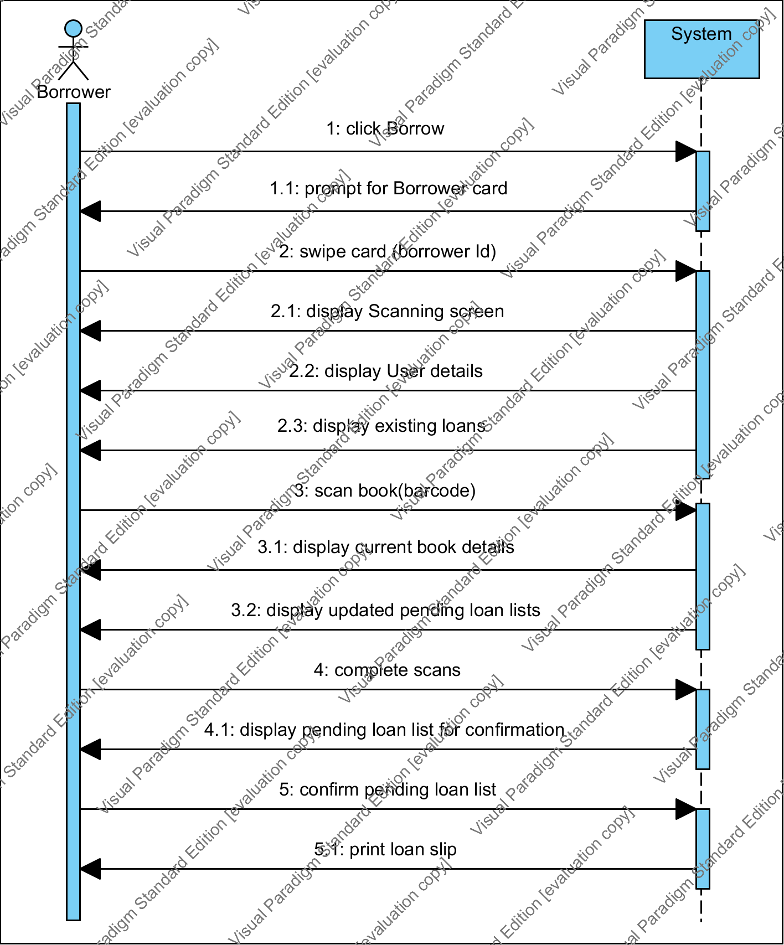

Borrow Book – Borrowing Not Restricted

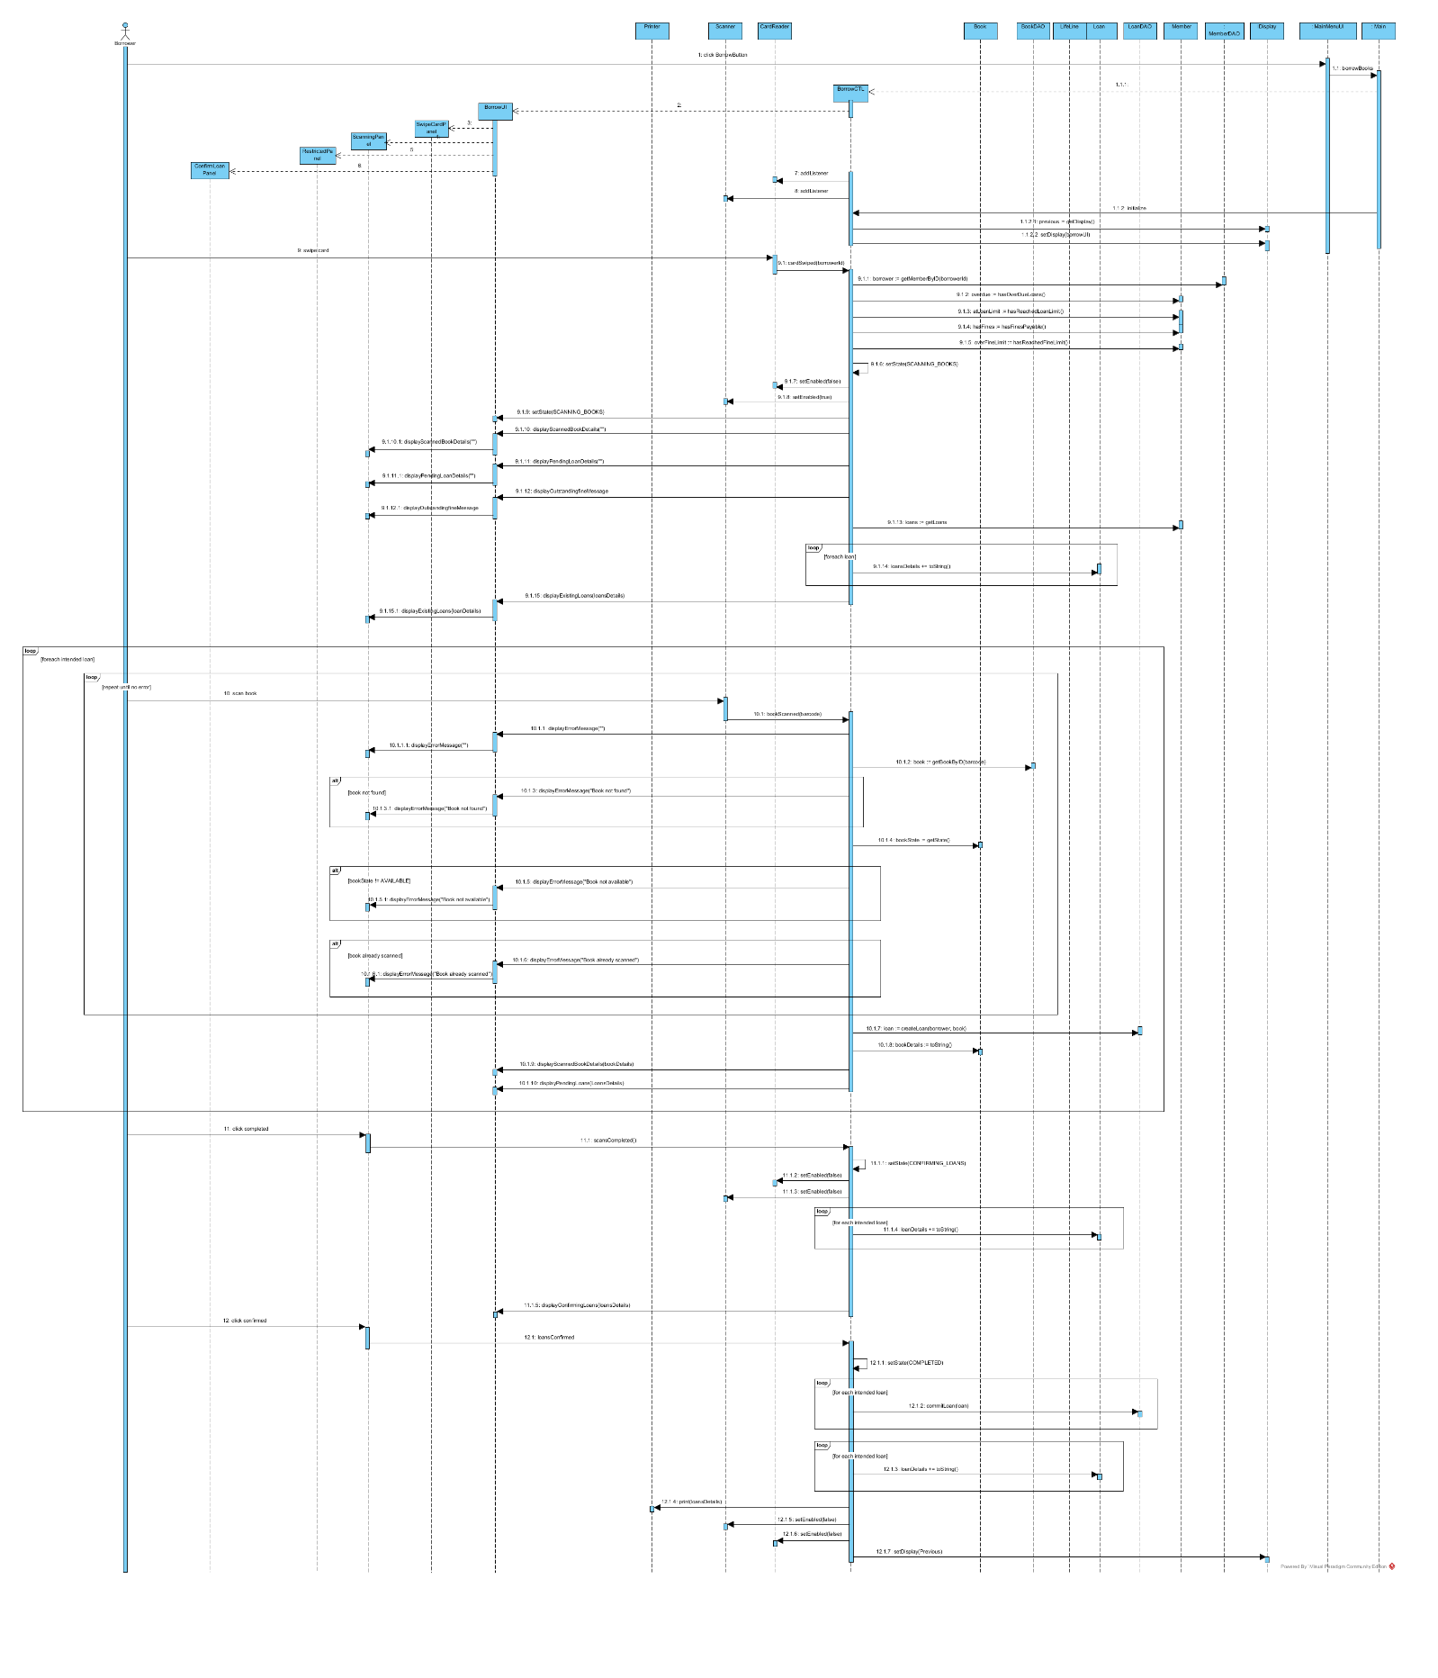

Borrow Book – Borrowing Restricted

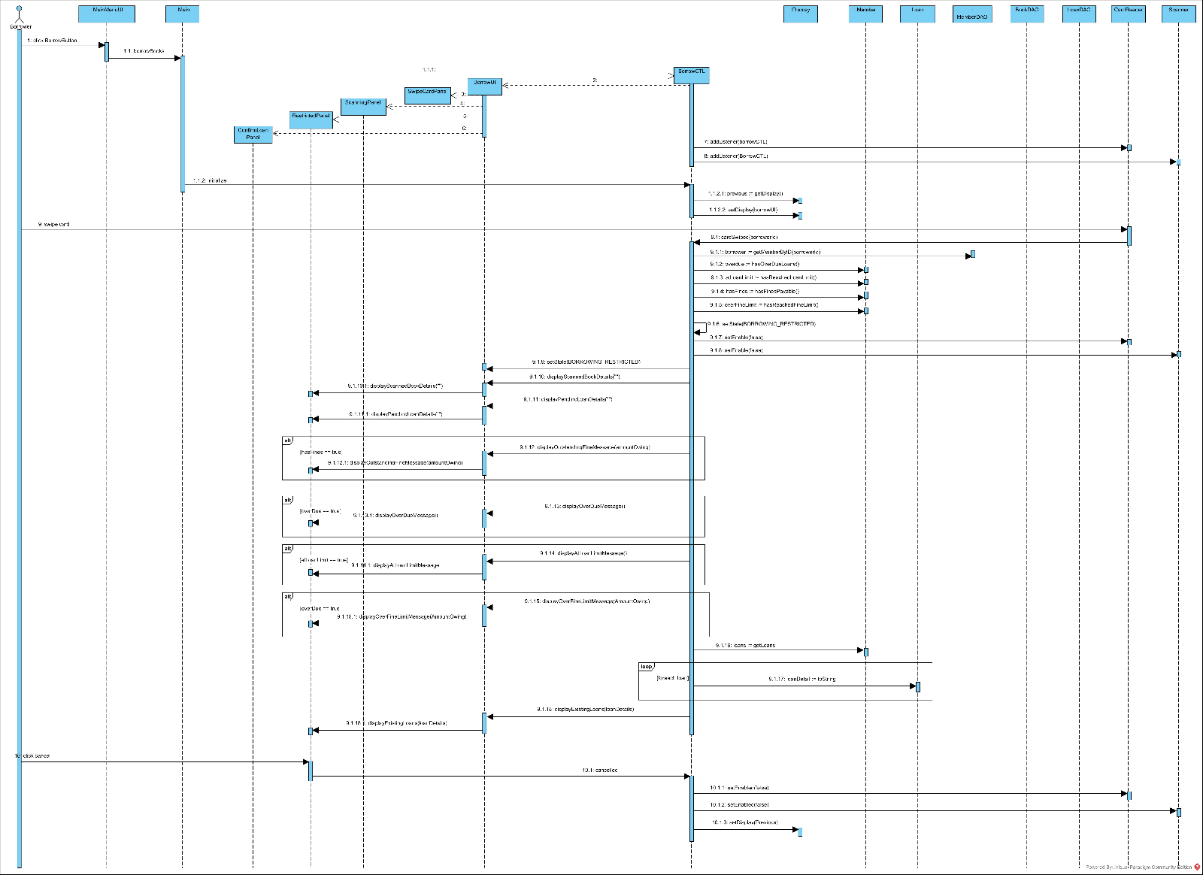

## Library System Domain Entities Software Specification

### Entities

**Member – implements IMember**

**Constructor** : Member

Parameters:

firstName:string, lastName:string, contactPhone :string, emailAddress:string, id:int

throws IllegalArgumentException if:

any of firstName, lastName, contactPhone, emailAddress are null or blank id is less than or

equal to zero

**hasOverDueLoans**: boolean

returns true if:

any existing loan is overdue

returns false otherwise

**hasReachedLoanLimit**: boolean

returns true if:

number of existing loans equal LOAN_LIMIT

returns false otherwise

**hasFinesPayable**: boolean

returns true if the fines owing by the Member exceeds zero

returns false otherwise

**hasReachedFineLimit**: boolean

returns true if:

the fines owing by the Member is equals or is greater than FINE_MAX

returns false otherwise

**getFineAmount**: float

returns the amount of fines owing by the Member

**addFine**: void

Parameters: amount:float

Increments the fines owing by amount

Throws IllegalArgumentException if:

amount is negative

**payFine**: void

Parameters: amount:float

Decrements the fines owing by amount

Throws IllegalArgumentException if:

amount is negative, or amount exceeds fines owing

**addLoan**: void

Parameters: loan:ILoan

Adds loan to the Members list of current loans

Throws IllegalArgumentException if:

loan is null ||

member is currently BORROWING_DISALLOWED

**getLoans**: List<ILoan>

returns a copy of the Members current loan list

**removeLoan**: void

Parameters: loan:ILoan

Removes a loan from the Members list of current loans

Throws IllegalArgumentException if:

loan is null, or loan not present in current loans

**getState**: EMemberState

returns the current MemberState of the Member

**getFirstName**: string

returns the firstName of the Member

**getLastName**: string

returns the lastName of the Member

**getContactPhone**: string

returns the contactPhone of the Member

**getEmailAddress**: string

returns the emailAddress of the Member

**getID**: int

returns the unique id of the member

**Book – implements IBook**

**Constructor**: Book

Parameters: author:String, title:String, callNumber:String, bookID:int

throws IllegalArgumentException if:

any of author, title, or callNumber are null or blank ||

bookID is less than or equal to zero

**borrow**: void

Parameters: loan:ILoan

associates the loan with the book

throws RuntimeException if:

the book is not currently AVAILABLE

**getLoan**: ILoan

returns the loan associated with the book

returns null if:

the book is not current ON_LOAN

**returnBook**: void

Parameters: damaged:boolean

removes the loan the book is associated with if:

damaged sets the BookState to DAMAGED

else

sets the BookState to AVAILABLE

throws RuntimeException if:

the book is not currently ON_LOAN

**lose**: void

sets the BookState to LOST

throws RuntimeException if:

the book is not currently ON_LOAN

**repair**: void

sets the BookState to AVAILABLE

throws RuntimeException if: the book is not currently DAMAGED

**dispose**: void

sets the BookState to DISPOSED

throws RuntimeException if:

the book is not currently AVAILABLE, DAMAGED, or LOST

**getState**: EBookState

returns the book’s current BookState

**getAuthor**: string

returns the book’s author

**getTitle**: string

returns the book’s title

**getCallNumber**: string

returns the book’s call number

**getID**: int

returns the book’s unique id

**Loan – implements ILoan**

**Constructor**: Loan

Parameters: book:IBook, borrower: IMember, borrowDate:Date, dueDate:Date, loanID:int

throws IllegalArgumentException if:

any of book, borrower, borrowDate, or dueDate are null

dueDate is less than borrowDate

loanID is less than or equal to zero

**commit**: void

sets the current state of the Loan to CURRENT

calls book.borrow with itself as parameter

calls borrower.addloan with itself as parameter

throws a RuntimeException if:

the loan’s current LoanState is not PENDING

**complete**: void

sets the current state of the Loan to COMPLETE

throws a RuntimeException if:

the loan’s current LoanState is not CURRENT or OVERDUE

**isOverDue**: boolean

returns true if current LoanState of loan is OVERDUE

**checkOverDue**: boolean

Parameters: currentDate:Date

Sets current LoanState to OVERDUE if currentDate > loan’s dueDate

throws a RuntimeException if:

the loan’s current LoanState is not CURRENT or OVERDUE

**getBorrower**: IMember

returns the borrower associated with the loan

**getBook**: book:IBook

returns the book associated with the loan

**getID**: id:int

returns the book’s unique id

### Data Access Objects

**BookDAO – implements IBookDAO**

**Constructor**: BookDAO

Parameters: helper:IBookHelper

throws IllegalArgumentException if helper is null

**addBook**: IBook

Parameters: author:string, title:string, callNumber:string

uses helper to create a new Book with a unique book ID

adds the new book to a collection of Books

returns the new book

**getBookByID**: IBook

Parameters: id:int

returns the book identified by the id from the Book collection

returns null if book not found

**listBooks**: List<IBook>

returns a list of all books in the Book collection

**findBooksByAuthor**: List<IBook>

Parameters: author:string

returns a list of all books in the collection written by author

returns empty list if no books found

**findBooksByTitle**: List<IBook>

Parameters: title:string

returns a list of all books in the collection whose title is title

returns empty list if no books found

**findBooksByAuthorTitle**: List<IBook>

Parameters: author:string , title:string

returns a list of all books in the collection whose title is title and whose author is author

returns empty list if no books found

**MemberDAO – implements IMemberDAO**

**Constructor**: MemberDAO

Parameters: helper:IMemberHelper

throws IllegalArgumentException if helper is null

**addMember**: IBook

Parameters: firstName:string, lastName :string, contactPhone :string, emailAddress:string

uses helper to create a new Member with a unique member ID

adds the new member to a collection of Members

returns the new member

**getMemberByID**: IMember

Parameters: id:int

returns the member identified by the id from the Member collection

returns null if member not found

**listBooks**: List<IMEMBER>

returns a list of all members in the Member collection

**findMembersByLastName**: List<IMember>

Parameters: lastName:string

returns a list of all members in the collection whose last name is lastName

returns empty list if no members found

**findMembersByEmailAddress**: List<IMember>

Parameters: emailAddress:string

returns a list of all members in the collection whose email address is emailAddress

returns empty list if no members found

**findMembersByNames**: List<IMember>

Parameters: firstName:string, lastName:string

returns a list of all members in the collection whose first name is firstName and whose

last name is lastName

returns empty list if no members found

**LoanDAO – implements ILoanDAO**

**Constructor**: LoanDAO

Parameters: helper:ILoanHelper

throws IllegalArgumentException if helper is null

**createLoan**: ILoan

Parameters: borrower:IMember, book:IBook

Uses helper to create a new loan with default id of zero

Returns new loan

throws IllegalArgumentException if borrower or book is null

**commitLoan**: ILoan

Assigns the loan a unique id

Stores the loan

**getLoanByID**: ILoan

Parameters: id:int

Returns the loan in the committed loan collection identified by id

Returns null if loan not found

**getLoanByBook**: ILoan

Parameters: book:IBook

Returns the loan in the committed loan collection associated with book

Returns null if loan not found

**listLoans**: List<ILoan>

Returns a list of all loans in the committed loan collection

**findLoansByBorrower**: List<ILoan>

Parameters: borrower:IMember

Returns a list of all loans in the committed loan collection associated with borrower

**findLoansByBookTitle**: List<ILoan>

Parameters: title:string

Returns a list of all loans in the committed loan collection associated with books with the title ‘title’

**updateOverDueStatus**: void

Parameters: date:Date

Iterates through the committed loan collection updating the overdue status of current

loans according to date.

**findOverDueLoans**: List<ILoan>

Returns a list of all loans in the committed loan collection which are currently overdue

### Helpers

**LoanHelper– implements ILoanHelper**

**makeLoan**: ILoan

Parameters: book:IBook, borrower:IMember, borrowDate:Date, dueDate:Date

returns a new loan with a default id of zero

**BookHelper– implements IBookHelper**

**makeBook**: IBook

Parameters: author: string, title: string, callNumber:string, id:int

returns a new book with an id specified by id

**MemberHelper– implements IMemberHelper**

**makeMember**: IMember

Parameters: firstName: string, lastName:string, contactPhone:string, emailAddress:string, id:int

returns a new book with an id specified by id

## Borrow Book System Operation Specifications

**BBUC_Op1:** Begin Use Case

**Intent:** Initialize Borrow Book Use Case

**Signature:** initialize()

**PreConditions:**

BorrowBookCTL class exists

memberDAO, loanDAO

bookDAO, display, cardReader,

scanner, printer all exist

BorrowBookCTL added as listener to

cardReader and scanner

BorrowBookCTL state == ***CREATED***

**PostConditions:**

BorrowBookUI is displayed

SwipeCard panel of BorrowBookUI displayed

Cancel button enabled

cardReader is enabled

scanner is disabled

BorrowBookCTL state == ***INITIALIZED***

**BBUC_Op2:** Swipe Borrower Card

**Intent:** Identify borrower to system

**Signature:** cardSwiped(borrowerId)

**PreConditions:**

cardReader visible and enabled

BorrowBookCTL added as listener to

cardReader

memberDAO exists

BorrowBookCTL state == ***INITIALIZED***

**PostConditions:**

**(member exists and not restricted)**

Scanning panel of BorrowBookUI displayed

Complete, Cancel buttons enabled

cardReader is disabled

scanner is enabled

borrower details displayed

existing loans displayed

scan count initialized as number of

existing loans

existing fine message displayed if relevant

BorrowBookCTL state == ***SCANNING_BOOKS***

**(member exists and is restricted)**

Restricted panel of BorrowBookUI displayed

Cancel button enabled

cardReader is disabled

scanner is disabled

borrower details displayed

existing loans displayed

existing fine message displayed if relevant

overdue message displayed if relevant

atLoanLimit message displayed if relevant

borrowing restricted error message displayed

BorrowBookCTL state ==

***BORROWING_RESTRICTED***

**BBUC_Op3:** Scan Book

**Intent:** Add book to list of intended/pending loans

**Signature:** bookScanned(barcode)

**PreConditions:**

BorrowBookCTL class exists

scanner exists

BorrowBookCTL added as listener to

scanner

BorrowBookCTL state == ***SCANNING_BOOKS***

**PostConditions:**

**(book not found)**

BorrowBookUI is displayed

Scanning panel of BorrowBookUI displayed

Cancel button enabled

cardReader is disabled

scanner is enabled

book not found error message displayed

BorrowBookCTL state == ***SCANNING_BOOKS***

**(book not available)**

BorrowBookUI is displayed

Scanning panel of BorrowBookUI displayed

Cancel button enabled

cardReader is disabled

scanner is enabled

book not available error message displayed

BorrowBookCTL state == ***SCANNING_BOOKS***

**(book already scanned)**

BorrowBookUI is displayed

Scanning panel of BorrowBookUI displayed

Cancel button enabled

cardReader is disabled

scanner is enabled

book already scanned error message

displayed

BorrowBookCTL state == ***SCANNING_BOOKS***

**(scan count < loan limit)**

BorrowBookUI is displayed

Scanning panel of BorrowBookUI displayed

Cancel button enabled

cardReader is disabled

scanner is enabled

scanCount incremented by 1

scanned books details displayed

new (pending) loan created

(pending) loan added to pending loan list

Current pending loan list displayed

BorrowBookCTL state == ***SCANNING_BOOKS***

**(scan count == loan limit)**

BorrowBookUI is displayed

ConfirmingLoans panel of BorrowBookUI

displayed

final pending loan list displayed

Cancel button enabled

Reject button enabled

cardReader is disabled

scanner is disabled

scanCount incremented by 1

BorrowBookCTL state == ***CONFIRMING_LOANS***

**BBUC_Op4:** Complete Scans

**Intent:** Finish scanning books

**Signature:** scansCompleted()

**PreConditions:**

BorrowBookCTL class exists

Pending loan list exists

BorrowBookCTL state == ***SCANNING_BOOKS***

**PostConditions:**

BorrowBookUI is displayed

Confirming Loan panel of BorrowBookUI

Is displayed

List of pending loans displayed

Cancel button enabled

cardReader is disabled

scanner is disabled

BorrowBookCTL state == ***CONFIRMING_LOANS***

**BBUC_Op5:** Confirm Loans

**Intent:** complete the borrowing book process

**Signature:** loansConfirmed()

**PreConditions:**

BorrowBookCTL class exists

Pending loan list exists

BorrowBookCTL state == ***CONFIRMING_LOANS***

**PostConditions:**

Main Menu is displayed

All pending loans are committed and recorded

Loan slip of committed loans printed

cardReader is disabled

scanner is disabled

BorrowBookCTL state == ***COMPLETED***

**BBUC_Op6:** Reject Loans

**Intent:** reject the current list of pending loans and

start the scanning process again

**Signature:** loansRejected()

**PreConditions:**

BorrowBookCTL class exists

Pending loan list exists

BorrowBookCTL state == ***CONFIRMING_LOANS***

**PostConditions:**

BorrowBookUI is displayed

Scanning panel of BorrowBookUI displayed

Borrower details displayed

Existing loan details displayed

pending loan list is empty

scan count == number of existing loans

Cancel button enabled

cardReader is disabled

scanner is enabled

BorrowBookCTL state == ***SCANNING_BOOKS***